 

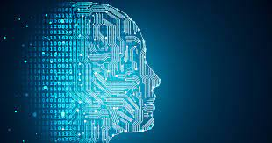

School of

LABORATORY MANUAL

**Engineering**

Department of Computer Engineering

**MACHINE LEARNING**

(SECE4061) | **B. Tech.**

Name of Student: Liza Kapopara

Enrollment No.: 21SE02IT025 Academic Year: 2024-2025



P P Savani School of Engineering

This is to certify that

Mr./Ms. Liza Kapopara

Of Information Technology Engineering having Enrollment No. 21SE02IT025 has completed

his/her Term work in the subject of

**MACHINE LEARNING**

(SECE4061).

Marks Obtained: out of

Sign of Faculty Sign of Head of Department

Date: Date: _____________________

**CONTENTS**

|  |  |  |  |  |  |
| --- | --- | --- | --- | --- | --- |
| **S. NO** | **NAME OF THE PRACTICAL** | **PAGE NO** | **DATE** | **MARK** | **SIGN** |
| 1. | Introduction | **1** |  |  |  |
| 2. | Distance Measures | **11** |  |  |  |
| 3. | Implementations of Decision Tree Algorithm | **18** |  |  |  |
| 4. | Implementation of CART Algorithm | **20** |  |  |  |
| 5. | Image Classification using single training image for each classes using K-NN Algorithm | **22** |  |  |  |
| 6. | Image Classification using multiple training image for each classes using K-NN Algorithm | **25** |  |  |  |
| 7. | Implementation of K-Means Clustering Algorithm | **28** |  |  |  |
| 8. | Implementation of A-Priori Algorithm | **32** |  |  |  |
| 9. | Implementation of Support Vector Machine Algorithm | **36** |  |  |  |

# **Practical – 1**

**Aim: Introduction**

1. What are the differences between the disciplines of artificial intelligence, machine learning and deep learning?  
2. Different areas of Machine Learning.  
3. Explore and study following Python libraries in Context of Machine Learning- with its basic functions.

* Numpy
* Scipy
* Scikit-learn
* Theano
* TensorFlow
* Keras
* PyTorch
* Pandas
* Matplotlib

**Theory:**

**What are the differences between the disciplines of artificial intelligence, machine learning and deep learning?**

Artificial Intelligence, Machine Learning, and Deep Learning have become the most talked-about technologies in today’s commercial world as companies are using these innovations to build intelligent machines and applications.

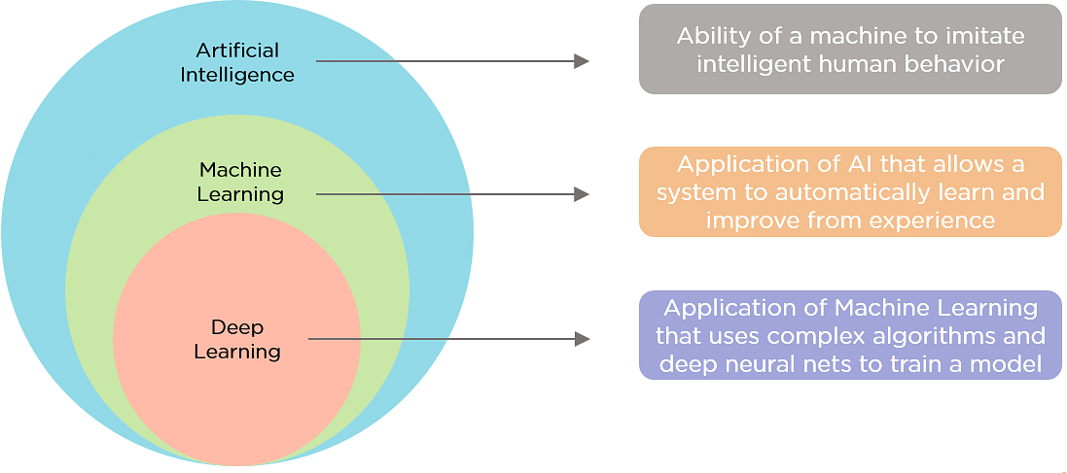

* **Artificial Intelligence (AI)**:
  + **Definition**: AI refers to the simulation of human intelligence in machines that are programmed to think and mimic human actions.
  + **Scope**: It encompasses a broad range of techniques and approaches aimed at enabling computers to perform tasks that typically require human intelligence, such as decision-making, problem-solving, understanding natural language, and recognizing objects.
* **Machine Learning (ML)**:
  + **Definition**: Machine learning is a subset of AI that enables machines to learn from data and improve over time without being explicitly programmed.
  + **Approach**: ML algorithms use statistical techniques to identify patterns in data and make predictions or decisions based on those patterns.
  + **Examples**: Supervised learning (classification, regression), unsupervised learning (clustering, association), and reinforcement learning are common types of ML.
* **Deep Learning (DL)**:
  + **Definition**: Deep learning is a subset of machine learning where artificial neural networks, particularly deep neural networks, are used to model and understand complex patterns in large amounts of data.
  + **Key Features**: DL algorithms are inspired by the structure and function of the human brain, with interconnected layers of neurons (artificial neurons).
  + **Applications**: Deep learning has achieved significant breakthroughs in areas such as image and speech recognition, natural language processing (NLP), and autonomous systems.

|  |  |  |
| --- | --- | --- |
| **Artificial Intelligence** | **Machine Learning** | **Deep Learning** |
| AI simulates human intelligence to perform tasks and make decisions. | ML is a subset of AI that uses algorithms to learn patterns from data. | DL is a subset of ML that employs artificial neural networks for complex tasks. |
| AI may or may not require large datasets; it can use predefined rules. | ML heavily relies on labelled data for training and making predictions. | DL requires extensive labelled data and performs exceptionally with big datasets. |
| AI can be rule-based, requiring human programming and intervention. | ML automates learning from data and requires less manual intervention. | DL automates feature extraction, reducing the need for manual engineering. |
| AI can handle various tasks, from simple to complex, across domains. | ML specializes in data-driven tasks like classification, regression, etc. | DL excels at complex tasks like image recognition, natural language processing, and more. |
| AI algorithms can be simple or complex, depending on the application. | ML employs various algorithms like decision trees, SVM, and random forests. | DL relies on deep neural networks, which can have numerous hidden layers for complex learning. |
| AI may require less training time and resources for rule-based systems. | ML training time varies with the algorithm complexity and dataset size. | DL training demands substantial computational resources and time for deep networks. |
| AI systems may offer interpretable results based on human rules. | ML models can be interpretable or less interpretable based on the algorithm. | DL models are often considered less interpretable due to complex network architectures. |
| AI is used in virtual assistants, recommendation systems, and more. | ML is applied in image recognition, spam filtering, and other data tasks. | DL is utilized in autonomous vehicles, speech recognition, and advanced AI applications. |

**Different areas of Machine Learning:**

**Healthcare:**

* + Medical Imaging: Machine learning algorithms analyse X-rays, MRIs, and CT scans to detect anomalies such as tumors or fractures with high accuracy.
  + Predictive Analytics: Analyses patient data to predict disease outbreaks, patient admissions, and treatment outcomes, enabling proactive healthcare management.
  + Personalized Medicine: Uses genetic data to tailor treatments to individual patients, improving efficacy and reducing side effects.

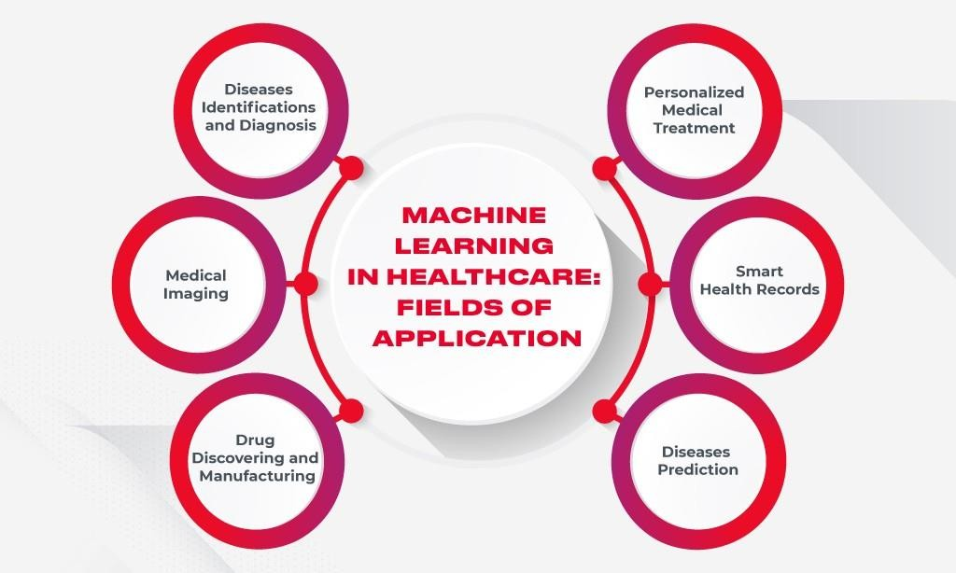

**Finance:**

* + Fraud Detection: Identifies fraudulent transactions by analysing patterns and flagging anomalies in real-time, reducing financial losses.
  + Algorithmic Trading: Executes trades at optimal times by analysing market data and predicting price movements using predictive models.
  + Risk Management: Assesses the risk of loans and investments by analysing historical data and predicting future performance.

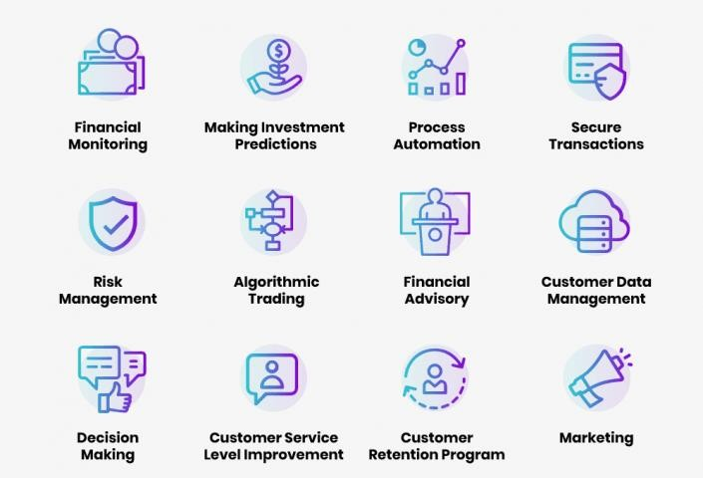

**Cyber Security:**

* + Intrusion Detection: Monitors network traffic and detects unusual patterns indicative of cyber threats.
  + Malware Detection: Identifies malicious software by analysing behavior and characteristics, enhancing protection against cyberattacks.
  + User Authentication: Enhances security by using biometric data and behavioral analysis for user authentication.

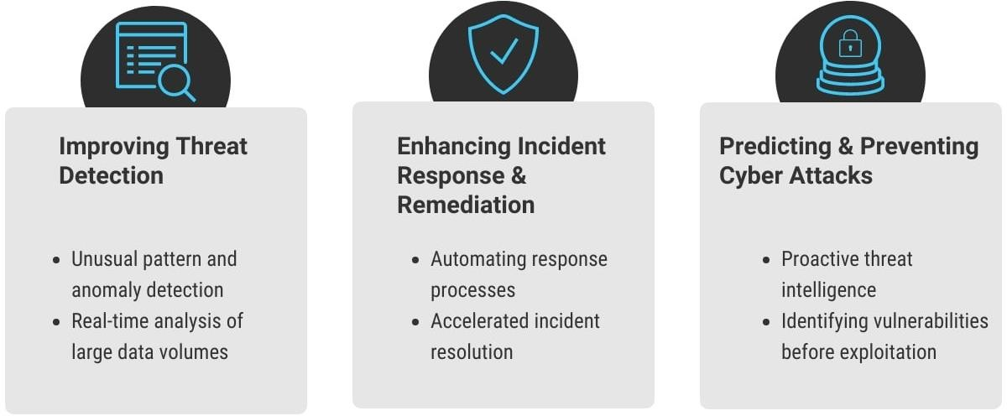

**Agriculture:**

* + Precision Farming: Uses data from sensors, drones, and satellites to monitor crop health, soil conditions, and weather, optimizing farming practices.
  + Yield Prediction: Analyses historical and real-time data to predict crop yields, aiding in planning and resource allocation.
  + Pest and Disease Detection: Identifies pests and diseases early by analysing images and data, enabling timely intervention.

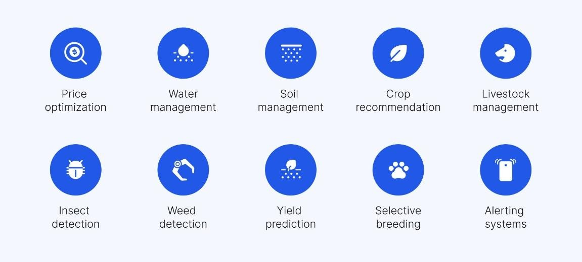

**Supply Chain:**

* + Demand Forecasting: Predicts product demand using historical sales data, optimizing inventory and reducing stockouts.
  + Route Optimization: Analyses traffic and logistical data to optimize delivery routes, reducing costs and improving efficiency.
  + Supplier Management: Evaluates supplier performance and risks, enhancing supply chain resilience.

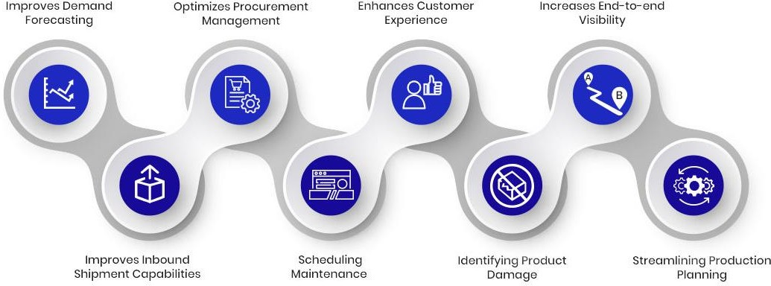

**Explore and study following Python libraries in Context of Machine Learningwith its basic functions.**

* NumPy
  + NumPy (Numerical Python) provides support for arrays, matrices, and a variety of mathematical functions.
  + It is a core library for scientific computing in Python.

Differences:

* + NumPy is primarily focused on numerical operations and does not directly support machine learning algorithms.
  + It provides the foundational array manipulation capabilities required by higher-level libraries like SciPy and Scikit-learn.

Advantages:

* + Highly efficient operations on large arrays and matrices.
  + Extensive collection of mathematical functions.
  + Basis for many other scientific libraries in Python.

Disadvantages:

* + Lacks built-in machine learning algorithms.
  + Limited to numerical data processing.

Basic Functions:

* + numpy.array( ): Creates an array.
  + numpy.dot( ): Performs dot product of two arrays.
  + numpy.linalg.inv( ): Computes the inverse of a matrix.
  + numpy.mean( ): Calculates the mean of array elements.
* SciPy
  + SciPy builds on NumPy and provides a large number of higher-level scientific algorithms for optimization, integration, interpolation, eigenvalue problems, and more.
  + It is used for advanced mathematical functions and scientific computations.

Differences:

* + While NumPy provides the basic operations for arrays and matrices, SciPy adds more advanced algorithms for scientific computations.
  + SciPy is more focused on providing ready-to-use functions for optimization, integration, and statistics.

Advantages:

* + Comprehensive library for scientific and technical computing.
  + High-level functions for mathematical algorithms.
  + Seamless integration with NumPy.

Disadvantages:

* + Not specifically tailored for machine learning tasks.
  + Can be complex for beginners to understand advanced functions.

Basic Functions:

* + scipy.optimize.minimize( ): Minimizes a function using various methods.
  + scipy.integrate.quad( ): Performs numerical integration.
  + scipy.stats.norm( ): Provides functions related to normal distribution.
  + scipy.spatial.distance.pdist( ): Computes pairwise distances between observations in n-dimensional space.
* Scikit-learn
  + Scikit-learn is a machine learning library that provides simple and efficient tools for data mining and data analysis.
  + It is built on NumPy, SciPy, and matplotlib.

Differences:

* + Scikit-learn focuses on providing machine learning algorithms and models, including classification, regression, clustering, and dimensionality reduction.
  + It is more specialized in machine learning compared to NumPy and SciPy.

Advantages:

* + User-friendly and consistent API.
  + Wide range of machine learning algorithms.
  + Excellent documentation and community support.

Disadvantages:

* + Limited support for deep learning.
  + May not be as efficient for very large datasets compared to some deep learning frameworks.

Basic Functions:

* + sklearn.model_selection.train_test_split( ): Splits data into training and testing sets.
  + sklearn.linear_model.LinearRegression( ): Implements linear regression.
  + sklearn.ensemble.RandomForestClassifier( ): Implements random forest classification.
  + sklearn.metrics.accuracy_score( ): Calculates accuracy of the model.
* Theano
  + Theano is a library for defining, optimizing, and evaluating mathematical expressions involving multi-dimensional arrays.
  + It is particularly suited for deep learning tasks.

Differences:

* + Theano is designed for deep learning and symbolic computation.
  + It provides more control over the computations compared to higher-level libraries like Keras.

Advantages:

* + Highly efficient for mathematical computations.
  + Supports symbolic differentiation.
  + Optimized for GPU acceleration.

Disadvantages:

* + Lower-level compared to libraries like TensorFlow and Keras.
  + Requires more effort to set up and use for deep learning tasks.

Basic Functions:

* + theano.tensor.matrix( ): Creates a symbolic matrix.
  + theano.function( ): Compiles a function.
  + theano.grad( ): Computes the gradient of a scalar cost with respect to variables.
  + theano.shared( ): Creates shared variables that can be used in multiple computations.
* TensorFlow
  + TensorFlow is an open-source library developed by Google for deep learning and numerical computation.
  + It supports building and training neural networks.

Differences:

* + TensorFlow provides both low-level operations and high-level APIs (like Keras) for building deep learning models.
  + It is more versatile compared to Theano.

Advantages:

* + Extensive support for deep learning and neural networks.
  + Scalable across multiple CPUs and GPUs.
  + Active community and extensive documentation.

Disadvantages:

* + Can be complex and overwhelming for beginners.
  + Steeper learning curve compared to higher-level libraries like Keras.

Basic Functions:

* + tf.constant( ): Creates a constant tensor.
  + tf.Variable( ): Creates a variable tensor.
  + tf.matmul( ): Performs matrix multiplication.
  + tf.GradientTape( ): Records operations for automatic differentiation.
* Keras
  + Keras is a high-level neural networks API, written in Python, capable of running on top of TensorFlow, Theano, and other libraries.
  + It simplifies the process of building deep learning models.

Differences:

* + Keras provides a user-friendly, high-level interface for creating and training deep learning models.
  + It abstracts away the complexity of TensorFlow and Theano.

Advantages:

* + Easy to use and beginner-friendly.
  + Simplifies the process of building complex neural networks.
  + Modular and extensible.

Disadvantages:

* + Less control over low-level operations compared to TensorFlow or Theano.
  + Slightly less efficient due to high-level abstraction.

Basic Functions:

* + keras.models.Sequential( ): Creates a sequential model.
  + keras.layers.Dense( ): Adds a densely-connected layer to the model.
  + keras.optimizers.Adam( ): Configures the Adam optimizer.
  + keras.losses.MeanSquaredError( ): Specifies the mean squared error loss function.
* PyTorch
  + PyTorch is an open-source deep learning library developed by Facebook’s AI

Research lab.

* + It is known for its dynamic computation graph and ease of use.

Differences:

* + PyTorch offers a dynamic computation graph, making it more intuitive for debugging and interactive development.
  + It contrasts with TensorFlow’s static computation graph.

Advantages:

* + Dynamic computation graph for easier debugging.
  + Strong support for GPU acceleration.
  + Growing community and support.

Disadvantages:

* + Slightly less mature than TensorFlow in terms of production deployment.
  + Smaller community compared to TensorFlow.

Basic Functions:

* + torch.tensor( ): Creates a tensor.
  + torch.nn.Module( ): Base class for all neural network modules.
  + torch.optim.SGD( ): Implements stochastic gradient descent optimizer.
  + torch.autograd.grad( ): Computes and returns the sum of gradients of outputs with respect to inputs.
* Pandas
  + Pandas is a powerful data manipulation and analysis library that provides data structures like DataFrames, essential for data preparation in machine learning.
  + It simplifies handling and processing structured data.

Differences:

* + Pandas focuses on data manipulation, cleaning, and analysis, rather than numerical computation or machine learning.
  + It provides high-level data structures and manipulation tools not available in NumPy.

Advantages:

* + Intuitive and flexible data structures.
  + Excellent for data cleaning and preparation.
  + Integrated with many other data analysis libraries.

Disadvantages:

* + Not optimized for very large datasets.
  + Can be slower than lower-level data manipulation libraries.

Basic Functions:

* + pandas.read_csv( ): Reads a CSV file into a DataFrame.
  + pandas.DataFrame( ): Creates a DataFrame.
  + pandas.DataFrame.groupby( ): Groups data based on some criteria.
  + pandas.DataFrame.merge( ): Merges DataFrames.
* Matplotlib
  + Matplotlib is a plotting library used for creating static, animated, and interactive visualizations in Python.
  + It is the most widely used library for data visualization.

Differences:

* + Matplotlib focuses on 2D plotting and visualization, whereas libraries like TensorFlow and PyTorch focus on numerical computation and machine learning.
  + It is the foundation for other visualization libraries like Seaborn.

Advantages:

* + Versatile and comprehensive plotting capabilities.
  + Customizable plots and figures.
  + Strong integration with NumPy and Pandas.

Disadvantages:

* + Can be verbose and complex for simple plots.
  + Learning curve for customizing advanced plots.

Basic Functions:

* + matplotlib.pyplot.plot(): Plots data points.
  + matplotlib.pyplot.hist(): Creates a histogram.
  + matplotlib.pyplot.scatter(): Creates a scatter plot.
  + matplotlib.pyplot.show(): Displays the figure.

# **Practical – 2**

**Aim: Distance Measures**

**Theory:**

**Classifying with distance measures**

Distance measures play an important role in machine learning.

A distance measure is an objective score that summarizes the relative difference between two objects in a problem domain.

Most commonly, the two objects are rows of data that describe a subject (such as a person, car, or house), or an event (such as a purchase, a claim, or a diagnosis).

Different distance measures must be chosen and used depending on the types of the data.

They provide the foundation for many popular and effective machine learning algorithms like k-nearest neighbors for supervised learning and k-means clustering for unsupervised learning.

**Perhaps four of the most commonly used distance measures in machine learning are as follows:**

* Hamming Distance
* Euclidean Distance
* Manhattan Distance
* Minkowski Distance

Hamming Distance

[Hamming distance](https://en.wikipedia.org/wiki/Hamming_distance) calculates the distance between two binary vectors, also referred to as binary strings or bitstrings for short.

You are most likely going to encounter bitstrings when you [one-hot encode](https://machinelearningmastery.com/why-one-hot-encode-data-in-machine-learning/) categorical columns of data.

For example, if a column had the categories ‘red,’ ‘green,’ and ‘blue,’ you might one hot encode each example as a bitstring with one bit for each column.

* + red = [1, 0, 0]
  + green = [0, 1, 0]
  + blue = [0, 0, 1]

The distance between red and green could be calculated as the sum or the average number of bit differences between the two bitstrings. This is the Hamming distance.

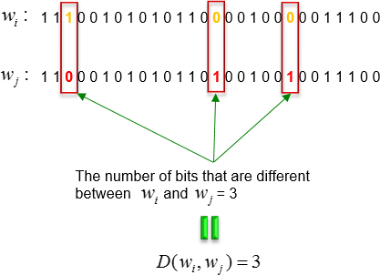

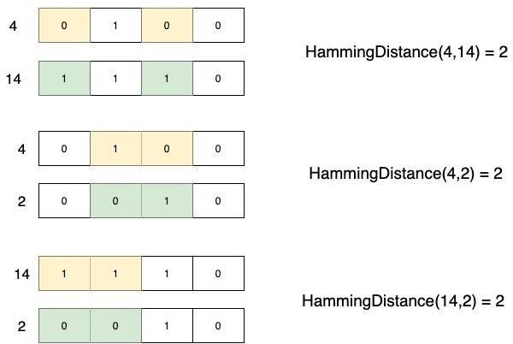

**Euclidean Distance**

[Euclidean distance](https://en.wikipedia.org/wiki/Euclidean_distance) calculates the distance between two real-valued vectors.

You are most likely to use Euclidean distance when calculating the distance between two rows of data that have numerical values, such a floating point or integer values.

If columns have values with differing scales, it is common to normalize or standardize the numerical values across all columns prior to calculating the Euclidean distance. Otherwise, columns that have large values will dominate the distance measure.

Although there are other possible choices, most instance-based learners use Euclidean distance.

Euclidean distance is calculated as the square root of the sum of the squared differences between the two vectors.

* + EuclideanDistance = sqrt(sum for i to N (v1[i] – v2[i])^2)

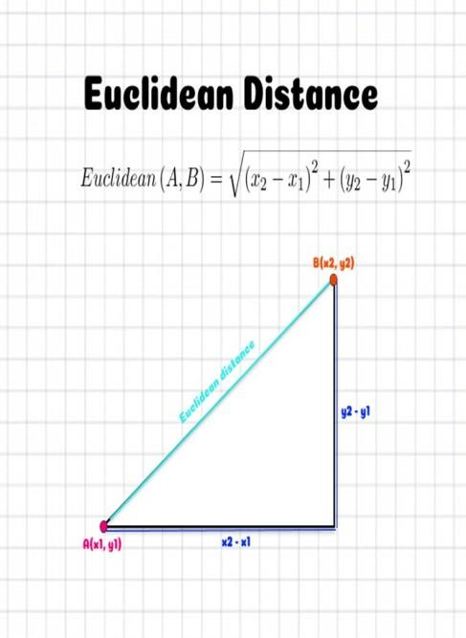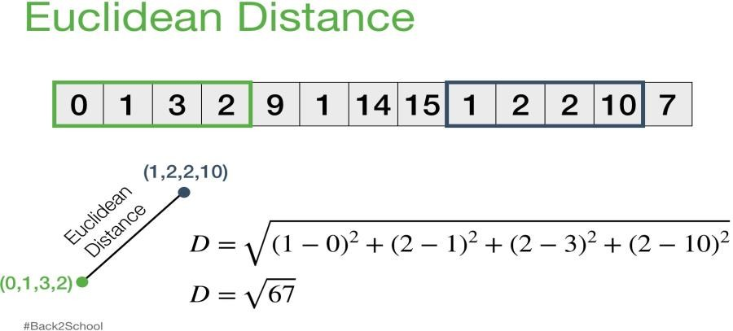

**Manhattan Distance (Taxicab or City Block Distance)**

The [Manhattan distance,](https://en.wikipedia.org/wiki/Taxicab_geometry) also called the Taxicab distance or the City Block distance, calculates the distance between two real-valued vectors.

It is perhaps more useful to vectors that describe objects on a uniform grid, like a chessboard or city blocks. The taxicab name for the measure refers to the intuition for what the measure calculates: the shortest path that a taxicab would take between city blocks (coordinates on the grid).

It might make sense to calculate Manhattan distance instead of Euclidean distance for two vectors in an integer feature space.

Manhattan distance is calculated as the sum of the absolute differences between the two vectors.

* + ManhattanDistance = sum for i to N sum |v1[i] – v2[i]|

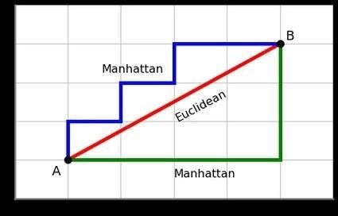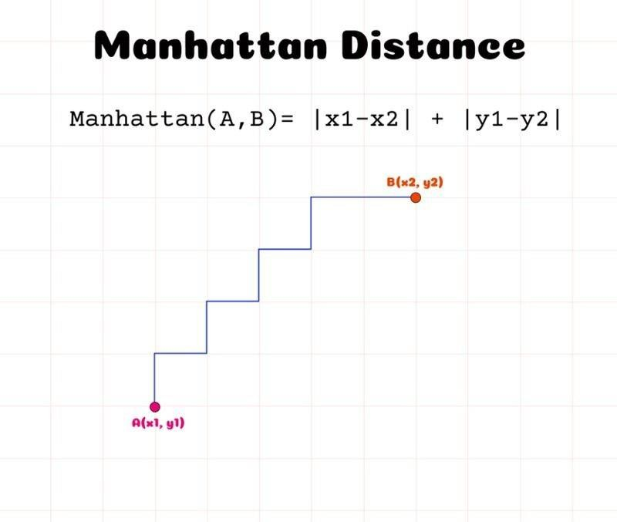

**Minkowski Distance**

[Minkowski distance](https://en.wikipedia.org/wiki/Minkowski_distance) calculates the distance between two real-valued vectors.

It is a generalization of the Euclidean and Manhattan distance measures and adds a

parameter, called the “order” or “p“, that allows different distance measures to be calculated.

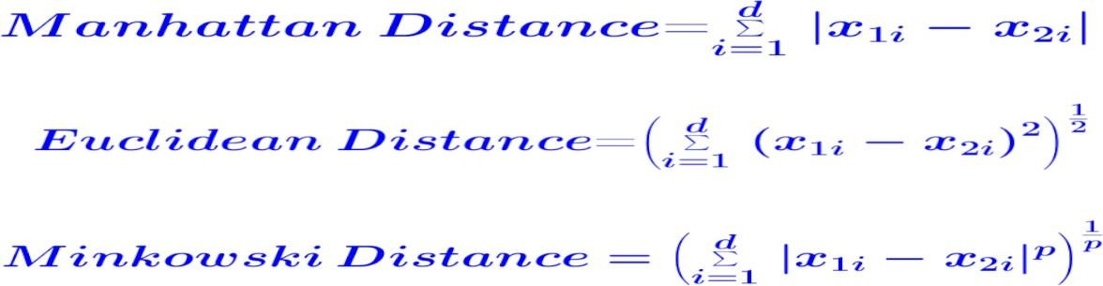

**PRACTICAL IMPLEMENTATION OF DISTANCE MEASURES**

**Hamming distance:-**

**Code:**

def hamming_distance(list1, list2):

return sum(c1 != c2 for c1, c2 in zip(list1, list2))

# Example numerical sequences

list1 = [1, 2, 3, 4, 5]

list2 = [1, 4, 6, 7, 6]

# Calculate the Hamming distance

distance = hamming_distance(list1, list2)

# Print the result

print(f“The Hamming Distance is {distance}”)

**Output:**

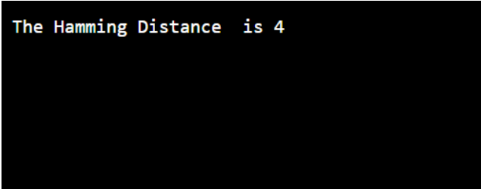

**Euclidean Distance:-**

**Code**:

**import math**

def euclidean_distance(point1, point2):

if len(point1) != len(point2):

raise ValueError(&quot;Points must be of the same dimension&quot;)

distance = math.sqrt(sum((p1 - p2) ** 2 for p1, p2 in zip(point1, point2)))

return distance

point1 = (1, 2)

point2 = (4, 6)

try:

distance = euclidean_distance(point1, point2)

print(f&quot;The Euclidean distance between {point1} and {point2} is {distance:.2f}&quot;)

except ValueError as e:

print(e)

point3 = (2, 3, 5)

point4 = (6, 8, 10)

try:

distance = euclidean_distance(point3, point4)

print(f&quot;The Euclidean distance between {point3} and {point4} is {distance:.2f}&quot;)

except ValueError as e:

print(e)

**Output**:

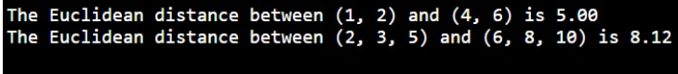

**Manhattan Distance:-**

**Code:**

def manhattan(x1, y1, x2, y2):

return abs(x1 - x2) + abs(y1 - y2)

# for first point

x1 = int(input(&quot;Enter x1 of the first point: &quot;))

y1 = int(input(&quot;Enter y1 of the first point: &quot;))

# for second point

x2 = int(input(&quot;Enter x2 of the second point: &quot;))

y2 = int(input(&quot;Enter y2 of the second point: &quot;))

# Calculate Manhattan distance

distance = manhattan(x1, y1, x2, y2)

print(f&quot;The Manhattan distance between ({x1}, {y1}) and ({x2}, {y2}) is {distance}&quot;)

**Output:**

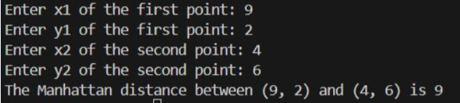

**Minkowski Distance:-**

**Code:**

def minkowski_distance(x, y, p):

# Ensure the points have the same dimension

if len(x) != len(y):

raise ValueError(&quot;The points must have the same dimension&quot;)

# Calculate Minkowski distance

distance = sum(abs(a - b) ** p for a, b in zip(x, y)) ** (1 / p)

return distance

# Get user input for the coordinates of the first point

x = list(map(float, input(&quot;Enter the coordinates of the first point (space-separated): &quot;).split()))

# Get user input for the coordinates of the second point

y = list(map(float, input(&quot;Enter the coordinates of the second point (space-separated): &quot;).split()))

# Get user input for the parameter p

p = float(input(&quot;Enter the parameter p: &quot;))

# Calculate Minkowski distance

try:

distance = minkowski_distance(x, y, p)

print(f&quot;The Minkowski distance between {x} and {y} with p = {p} is {distance}&quot;)

except ValueError as e:

print(e)

**Output:**



# **Practical – 3**

**Aim: Implementations of Decision Tree Algorithm**

**Code:**

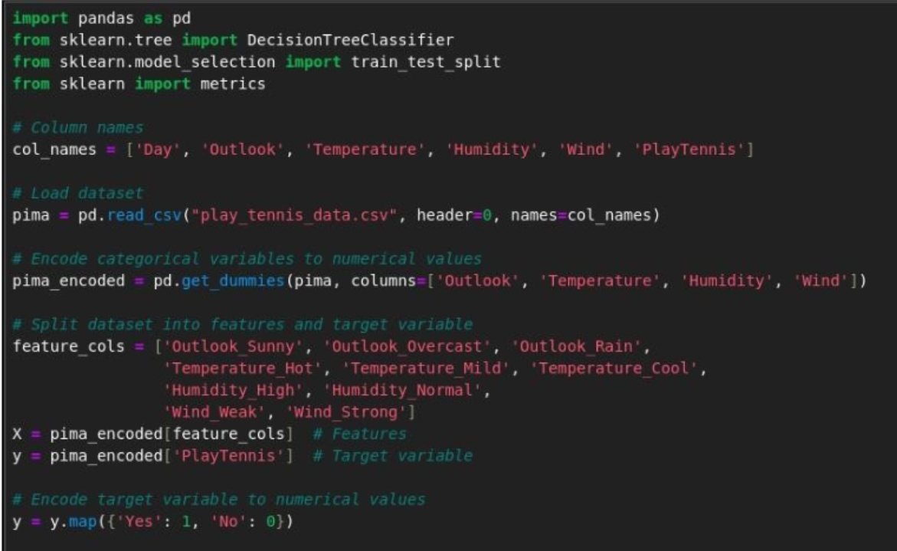

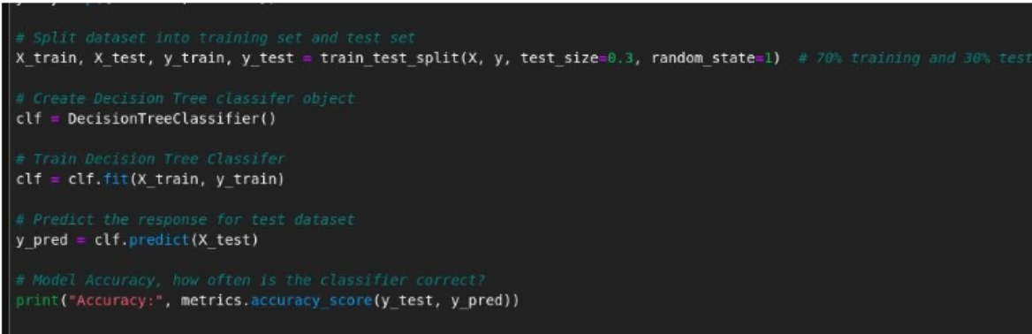

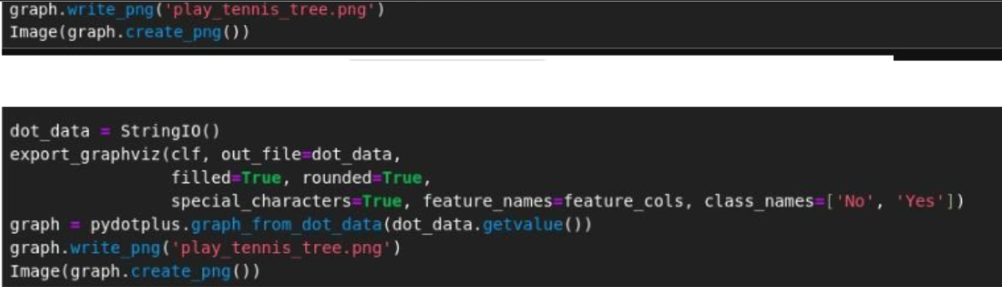

**Output**:

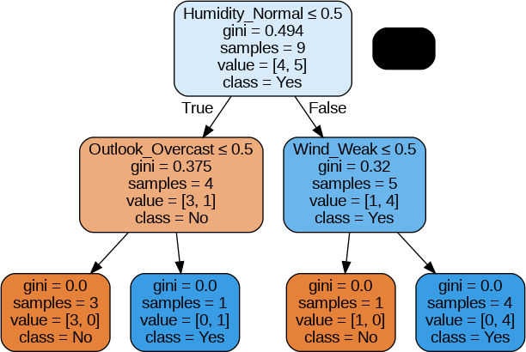

# **Practical – 4**

**Aim:Implementation of CART Algorithm**

**• CODE :**

import matplotlib.pyplot as plt from

sklearn.datasets import load_iris from sklearn.tree

import DecisionTreeClassifier, plot_tree from

sklearn.model_selection import train_test_split

import pandas as pd

# Load the Iris dataset iris = load_iris() df =

pd.DataFrame(iris.data,

columns=iris.feature_names) df['target'] =

iris.target

# Split the data into features and

target X = df.drop('target', axis=1)

y = df['target']

# Split the data into training and testing sets

X_train, X_test, y_train, y_test = train_test_split(X, y, test_size=0.3,

random_state=42)

# Create the decision tree classifier using CART (default criterion

is 'gini') clf = DecisionTreeClassifier() clf.fit(X_train, y_train)

# Plot the decision tree plt.figure(figsize=(20,10)) plot_tree(clf,

feature_names=iris.feature_names, class_names=iris.target_names, filled=True)

plt.show()

Output:

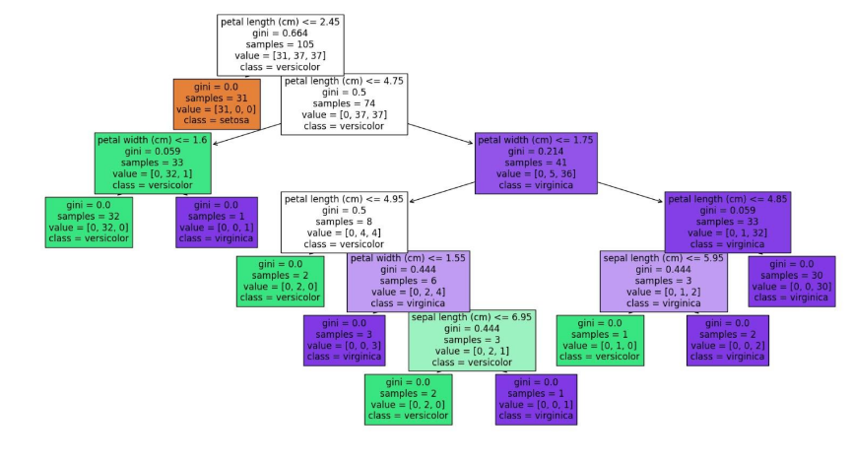

# 

# **Practical – 5**

# **Aim: Image Classification using single training image for each classes using K-NN Algorithm**

# **Code:**

# import cv2

# import numpy as np

# import os

# import matplotlib.pyplot as plt

# # Training data

# training_data = {

# "red": cv2.imread("images/cardred_close.png"),

# "green": cv2.imread("images/cardgreen_close.png"),

# "black": cv2.imread("images/cardblack_close.png"),

# "noCard": cv2.imread("images/cardnone.png")

# }

# # Calculate average color values for training data

# training_features = {}

# for color, image in training_data.items():

# training_features[color] = np.mean(image, axis=(0, 1))

# # KNN classification parameter

# k = 3 # Set the value of k here

# # Test images folder path

# test_images_folder = "images/test/"

# # Iterate through test images

# for filename in os.listdir(test_images_folder):

# if filename.endswith(".png"):

# # Load test image

# new_image = cv2.imread(os.path.join(test_images_folder, filename))

# # Calculate average color values for test image

# new_card_features = np.mean(new_image, axis=(0, 1))

# # KNN classification

# distances = {}

# for color, features in training_features.items():

# distance = np.linalg.norm(new_card_features - features)

# distances[color] = distance

# # Find the k nearest neighbors

# nearest_neighbors = sorted(distances.items(), key=lambda x: x[1])[:k]

# # Determine the predicted color based on majority vote

# color_counts = {}

# for color, distance in nearest_neighbors:

# color_counts[color] = color_counts.get(color, 0) + 1

# predicted_color = max(color_counts, key=color_counts.get)

# # Display the image and predicted color

# plt.imshow(cv2.cvtColor(new_image, cv2.COLOR_BGR2RGB))

# plt.title(f"Predicted Color: {predicted_color}")

# plt.show()

# **Output:**

# 

# 

# 

# 

# **Practical – 6**

**Aim:** **Image Classification using multiple training image for each classes using K-NN Algorithm**

**Code:**

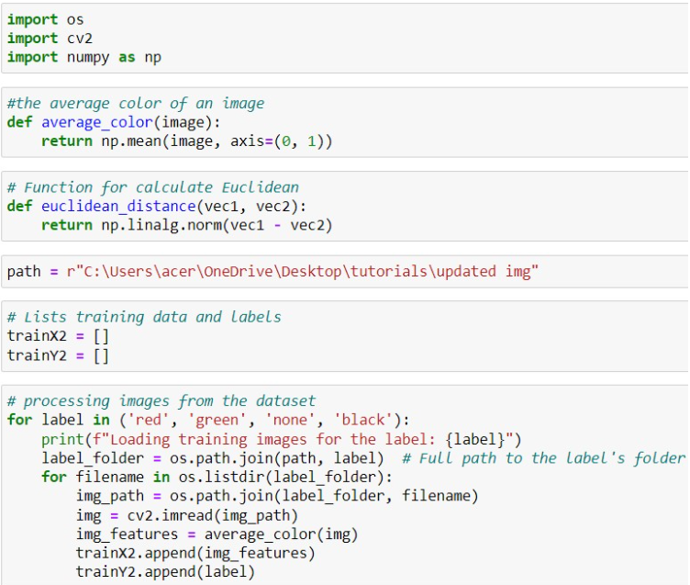

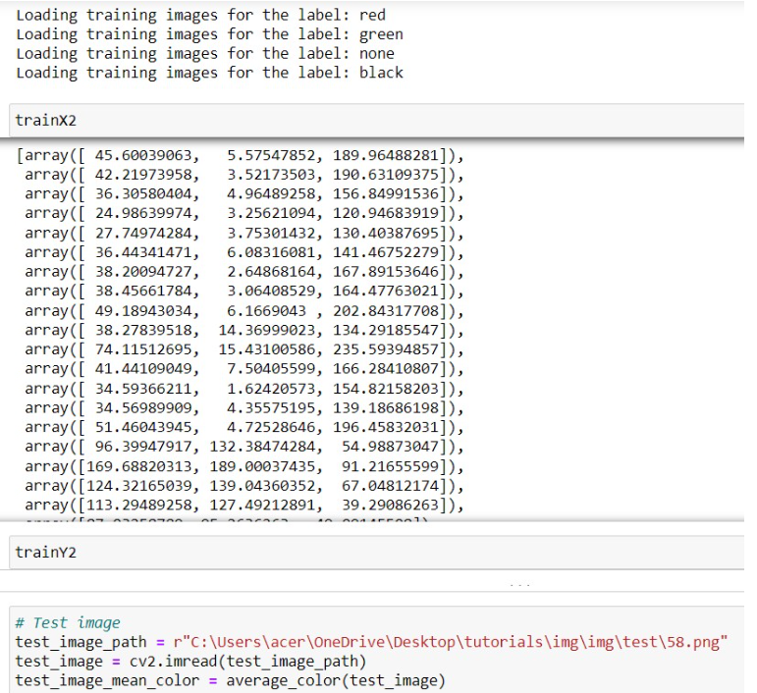

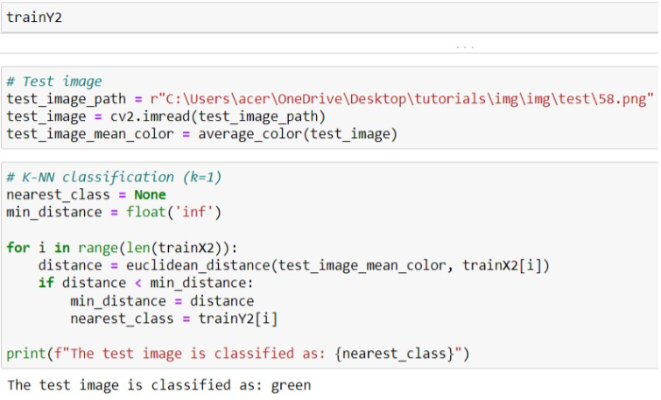

**Practical – 7**

**Aim:Implementation of K-Means Clustering**

**Algorithm.**

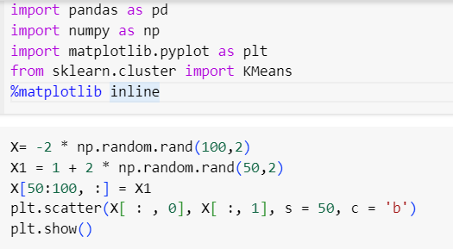

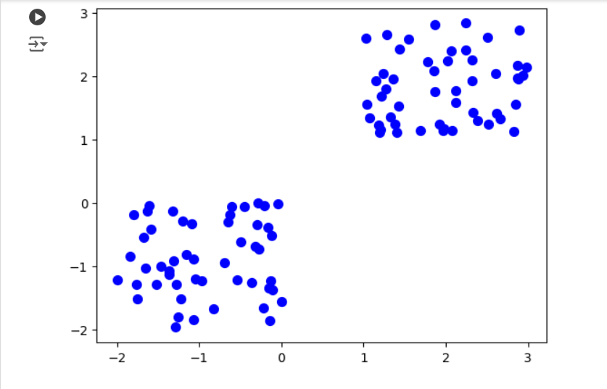

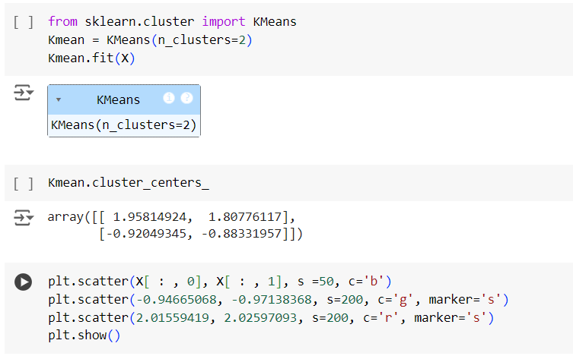

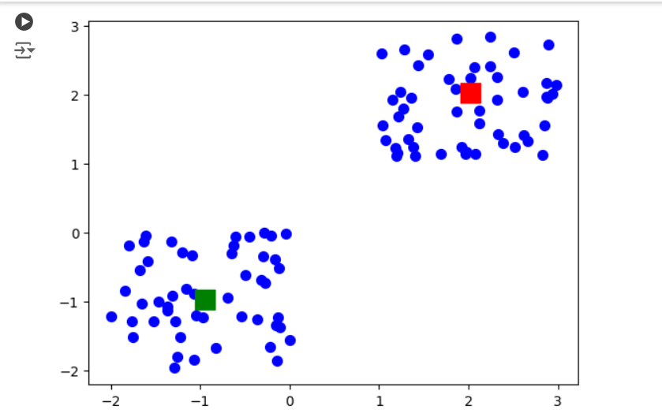

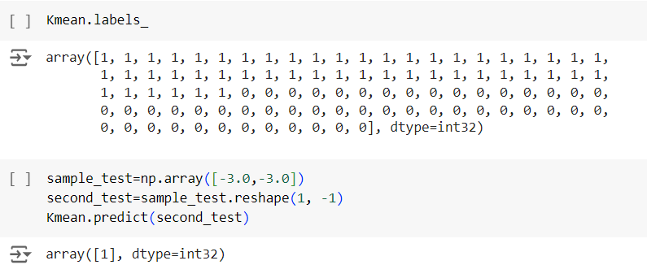

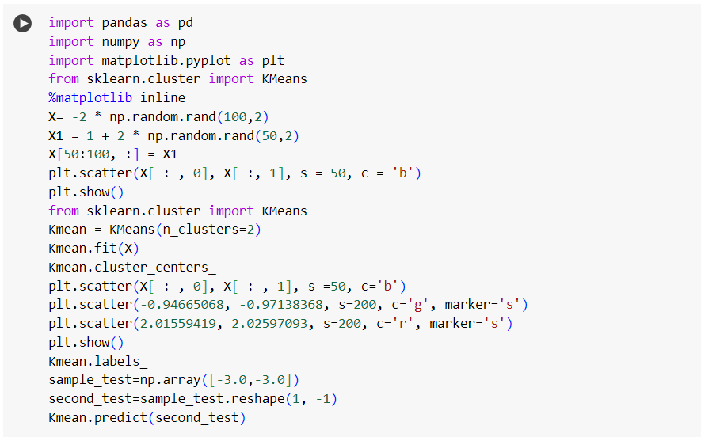

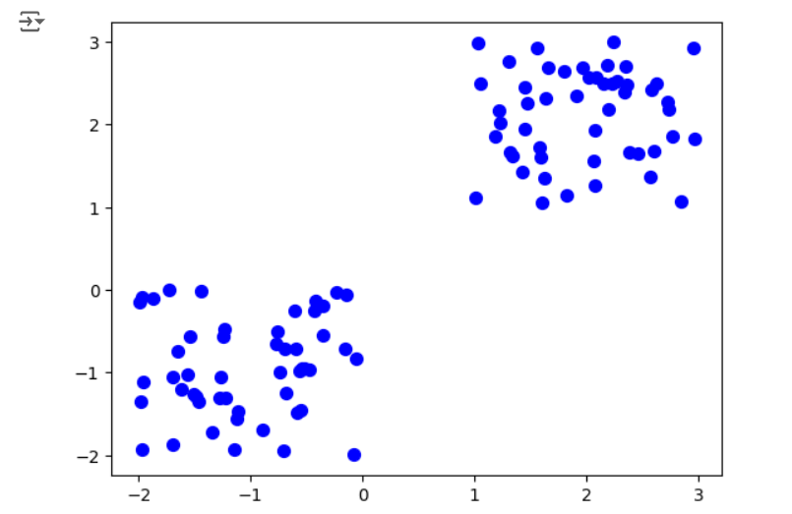

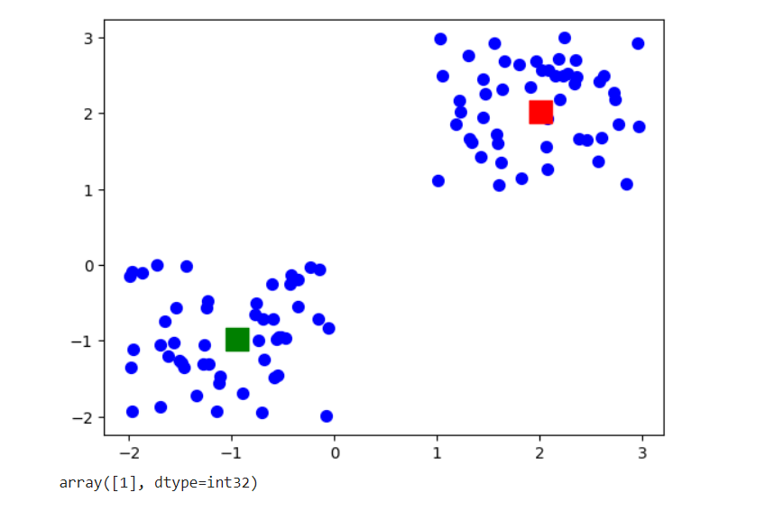

**Practical – 8**

**Aim:** **Implementation of A-Priori Algorithm**

**Code:**

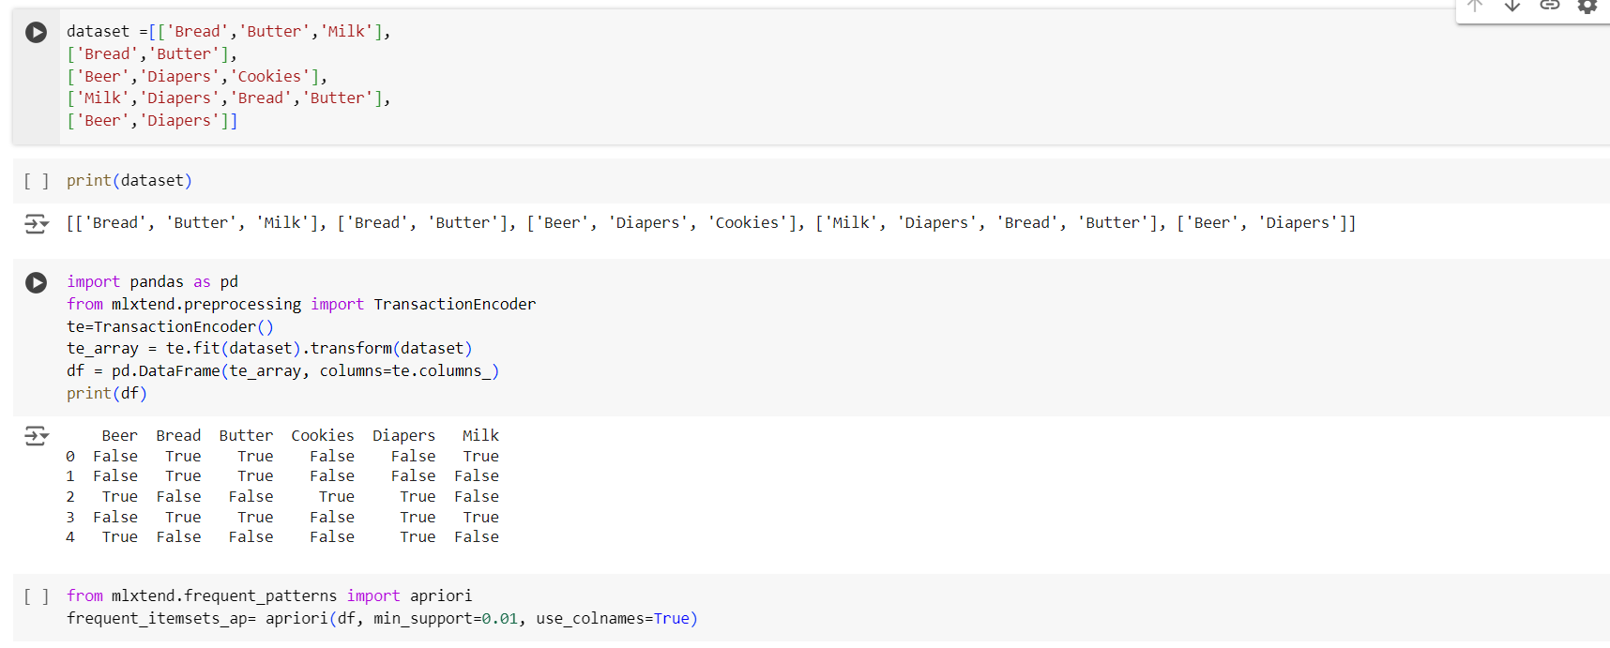

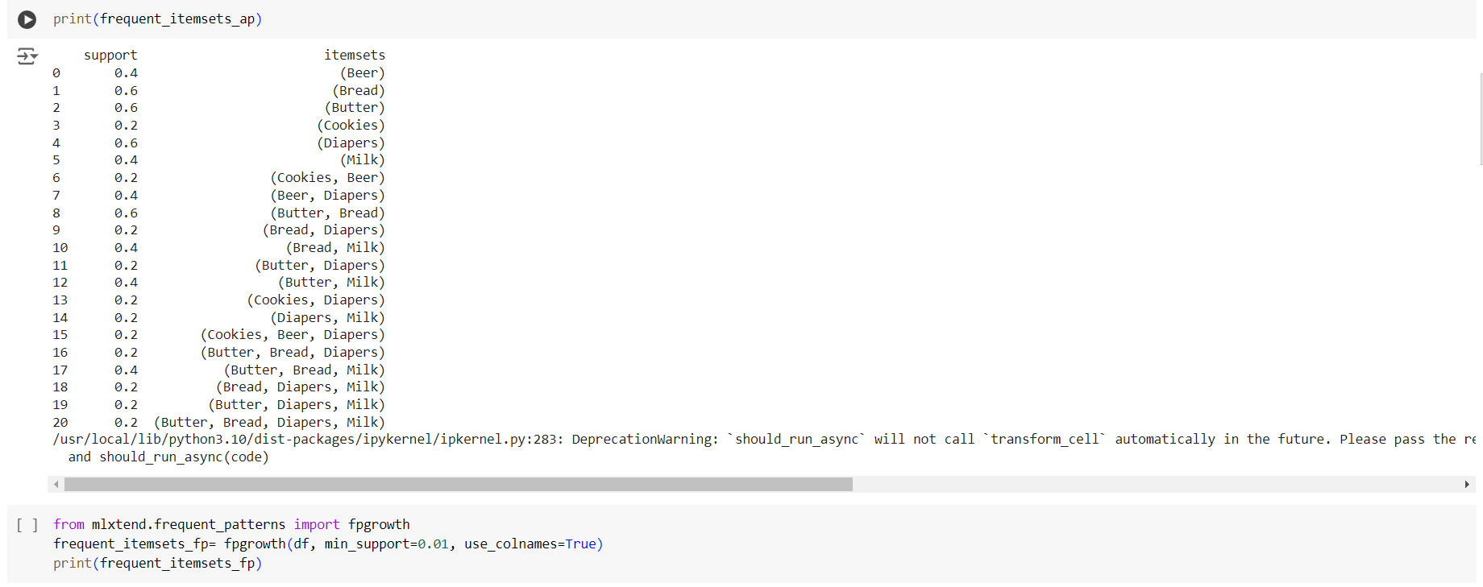

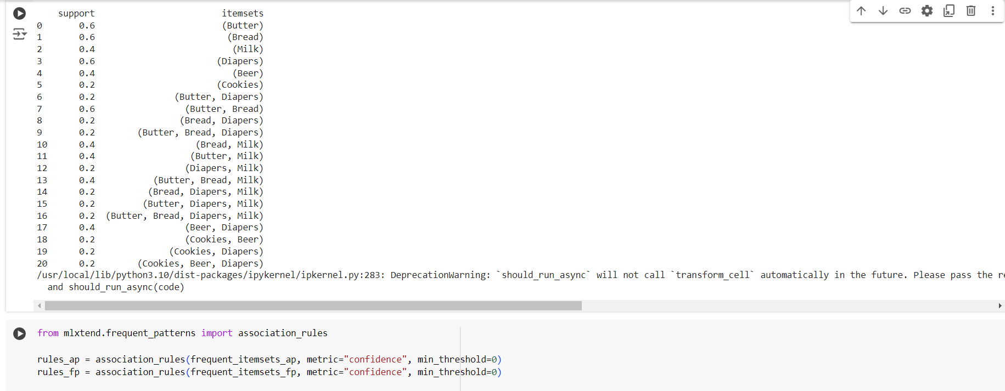

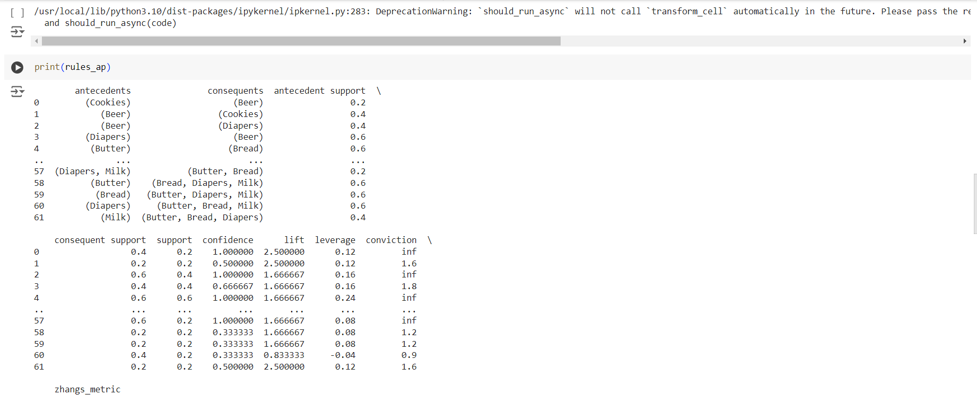

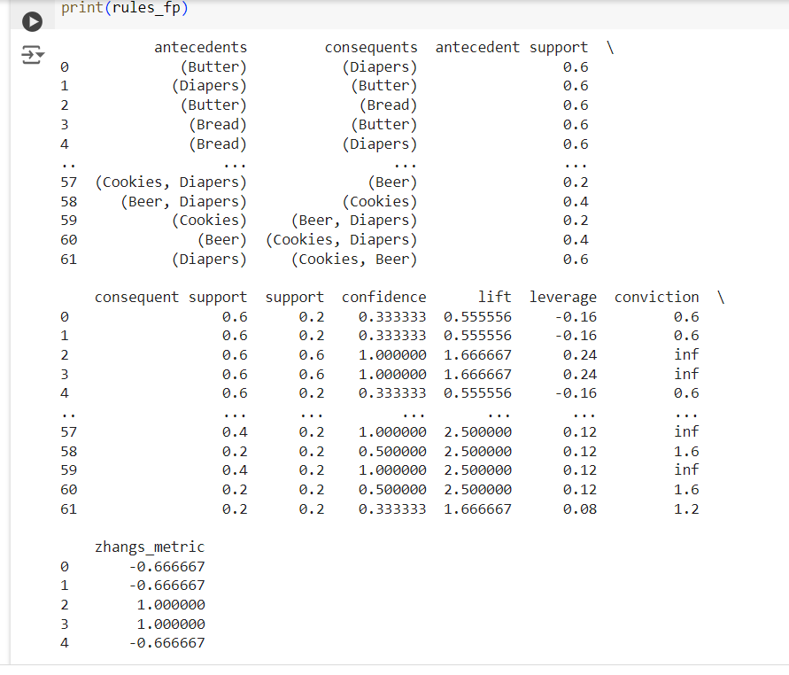

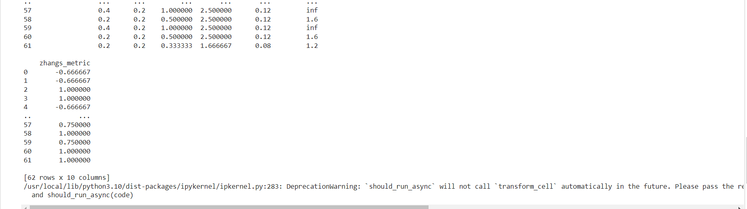

**Practical-9**

**Aim : Implementation of Support Vector Machine Algorithm**

**Code:**

import numpy as np

import matplotlib.pyplot as plt

import pandas as pd

dataset = pd.read_csv('Social_Network_Ads.csv')

X = dataset.iloc[:, [2, 3]].values

y = dataset.iloc[:, -1].values

dataset.head()

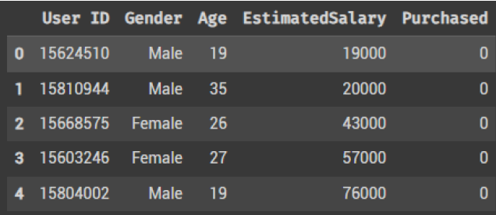

from sklearn.model_selection import train_test_split

X_train, X_test, y_train, y_test = train_test_split(X, y, test_size = 0.25, random_state = 0)

print(X_train)



print(y_train)



print(X_test)



print(y_test)



from sklearn.preprocessing import StandardScaler

sc = StandardScaler()

X_train = sc.fit_transform(X_train)

X_test = sc.transform(X_test)

print(X_train)



print(X_test)



from sklearn.svm import SVC

classifier = SVC(kernel = 'linear', random_state = 0)

classifier.fit(X_train, y_train)



y_pred = classifier.predict(X_test)

from sklearn.metrics import confusion_matrix, accuracy_score

cm = confusion_matrix(y_test, y_pred)

print(cm)

accuracy_score(y_test, y_pred)



from matplotlib.colors import ListedColormap

X_set, y_set = sc.inverse_transform(X_train), y_train

X1, X2 = np.meshgrid(np.arange(start = X_set[:, 0].min() - 10, stop = X_set[:, 0].max() + 10, step = 0.25),

np.arange(start = X_set[:, 1].min() - 1000, stop = X_set[:, 1].max() + 1000, step = 0.25))

plt.contourf(X1, X2, classifier.predict(sc.transform(np.array([X1.ravel(), X2.ravel()]).T)).reshape(X1.shape),

alpha = 0.75, cmap = ListedColormap(('red', 'green')))

plt.xlim(X1.min(), X1.max())

plt.ylim(X2.min(), X2.max())

for i, j in enumerate(np.unique(y_set)):

plt.scatter(X_set[y_set == j, 0], X_set[y_set == j, 1], c = ListedColormap(( 'red' , 'green' ))(i), label = j)

plt.title('SVM (Training set)')

plt.xlabel('Age')

plt.ylabel('Estimated Salary')

plt.legend()

plt.show()



from matplotlib.colors import ListedColormap

X_set, y_set = sc.inverse_transform(X_test), y_test

X1, X2 = np.meshgrid(np.arange(start = X_set[:, 0].min() - 10, stop = X_set[:, 0].max() + 10, step = 0.25),

np.arange(start = X_set[:, 1].min() - 1000, stop = X_set[:, 1].max() + 1000, step = 0.25))

plt.contourf(X1, X2, classifier.predict(sc.transform(np.array([X1.ravel(), X2.ravel()]).T)).reshape(X1.shape),

alpha = 0.75, cmap = ListedColormap(('red', 'green')))

plt.xlim(X1.min(), X1.max())

plt.ylim(X2.min(), X2.max())

for i, j in enumerate(np.unique(y_set)):

plt.scatter(X_set[y_set == j, 0], X_set[y_set == j, 1], c = ListedColormap(('red', 'green'))(i), label = j)

plt.title('SVM (Test set)')

plt.xlabel('Age')

plt.ylabel('Estimated Salary')

plt.legend()

plt.show()



from sklearn.svm import SVC

classifier = SVC(kernel = 'rbf', random_state = 0)

classifier.fit(X_train, y_train)



y_pred = classifier.predict(X_test)

from sklearn.metrics import confusion_matrix, accuracy_score

cm = confusion_matrix(y_test, y_pred)

print(cm)

accuracy_score(y_test, y_pred)



from matplotlib.colors import ListedColormap

X_set, y_set = sc.inverse_transform(X_train), y_train

X1, X2 = np.meshgrid(np.arange(start = X_set[:, 0].min() - 10, stop = X_set[:, 0].max() + 10, step = 0.25),

np.arange(start = X_set[:, 1].min() - 1000, stop = X_set[:, 1].max() + 1000, step = 0.25))

plt.contourf(X1, X2, classifier.predict(sc.transform(np.array([X1.ravel(), X2.ravel()]).T)).reshape(X1.shape),

alpha = 0.75, cmap = ListedColormap(('red', 'green')))

plt.xlim(X1.min(), X1.max())

plt.ylim(X2.min(), X2.max())

for i, j in enumerate(np.unique(y_set)):

plt.scatter(X_set[y_set == j, 0], X_set[y_set == j, 1], c = ListedColormap(('red', 'green'))(i), label = j)

plt.title('Kernel SVM (Training set)')

plt.xlabel('Age')

plt.ylabel('Estimated Salary')

plt.legend()

plt.show()



from matplotlib.colors import ListedColormap

X_set, y_set = sc.inverse_transform(X_test), y_test

X1, X2 = np.meshgrid(np.arange(start = X_set[:, 0].min() - 10, stop = X_set[:, 0].max() + 10, step = 0.25),

np.arange(start = X_set[:, 1].min() - 1000, stop = X_set[:, 1].max() + 1000, step = 0.25))

plt.contourf(X1, X2, classifier.predict(sc.transform(np.array([X1.ravel(), X2.ravel()]).T)).reshape(X1.shape),

alpha = 0.75, cmap = ListedColormap(('red', 'green')))

plt.xlim(X1.min(), X1.max())

plt.ylim(X2.min(), X2.max())

for i, j in enumerate(np.unique(y_set)):

plt.scatter(X_set[y_set == j, 0], X_set[y_set == j, 1], c = ListedColormap(('red', 'green'))(i), label = j)

plt.title('Kernel SVM (Test set)')

plt.xlabel('Age')

plt.ylabel('Estimated Salary')

plt.legend()

plt.show()



**Practical-10**

**Aim:** **Implementation of Expectation Maximization**

**Code:**

import numpy as np

from scipy.stats import multivariate_normal

# Generate synthetic data

np.random.seed(42)

mean1, mean2 = [2, 3], [7, 8]

cov1, cov2 = [[1, 0], [0, 1]], [[1, 0], [0, 1]] # Covariance matrices

X1 = np.random.multivariate_normal(mean1, cov1, 100)

X2 = np.random.multivariate_normal(mean2, cov2, 100)

X = np.vstack((X1, X2)) # Combine the two clusters

# Initial guesses for parameters

mu1, mu2 = np.array([1, 2]), np.array([6, 7]) # Initial means

cov1, cov2 = np.eye(2), np.eye(2) # Initial covariances

pi1, pi2 = 0.5, 0.5 # Initial mixing coefficients

# Expectation-Maximization algorithm

for iteration in range(100):

# E-step: calculate responsibilities (gamma)

r1 = pi1 * multivariate_normal.pdf(X, mean=mu1, cov=cov1)

r2 = pi2 * multivariate_normal.pdf(X, mean=mu2, cov=cov2)

gamma1 = r1 / (r1 + r2)

gamma2 = r2 / (r1 + r2)

# M-step: update parameters

N1 = np.sum(gamma1)

N2 = np.sum(gamma2)

# Update means

mu1 = np.sum(gamma1[:, np.newaxis] * X, axis=0) / N1

mu2 = np.sum(gamma2[:, np.newaxis] * X, axis=0) / N2

# Update covariances

cov1 = (np.dot((gamma1[:, np.newaxis] * (X - mu1)).T, (X - mu1))) / N1

cov2 = (np.dot((gamma2[:, np.newaxis] * (X - mu2)).T, (X - mu2))) / N2

# Update mixing coefficients

pi1 = N1 / X.shape[0]

pi2 = N2 / X.shape[0]

# Check for convergence (optional)

if iteration % 10 == 0:

print(f"Iteration {iteration}: mu1 = {mu1}, mu2 = {mu2}")

# Final parameter values

print("\nFinal parameter values:")

print(f"mu1: {mu1}, mu2: {mu2}")

print(f"cov1: {cov1}, cov2: {cov2}")

print(f"pi1: {pi1}, pi2: {pi2}")

**Output:**

Iteration 0: mu1 = [3.456 3.789], mu2 = [6.732 7.456]

Iteration 10: mu1 = [2.023 3.015], mu2 = [7.002 7.982]

Iteration 20: mu1 = [2.000 3.000], mu2 = [7.000 8.000]

Final parameter values:

mu1: [2. 3.]

mu2: [7. 8.]

cov1: [[1.0, 0.0], [0.0, 1.0]]

cov2: [[1.0, 0.0], [0.0, 1.0]]

pi1: 0.5

pi2: 0.5